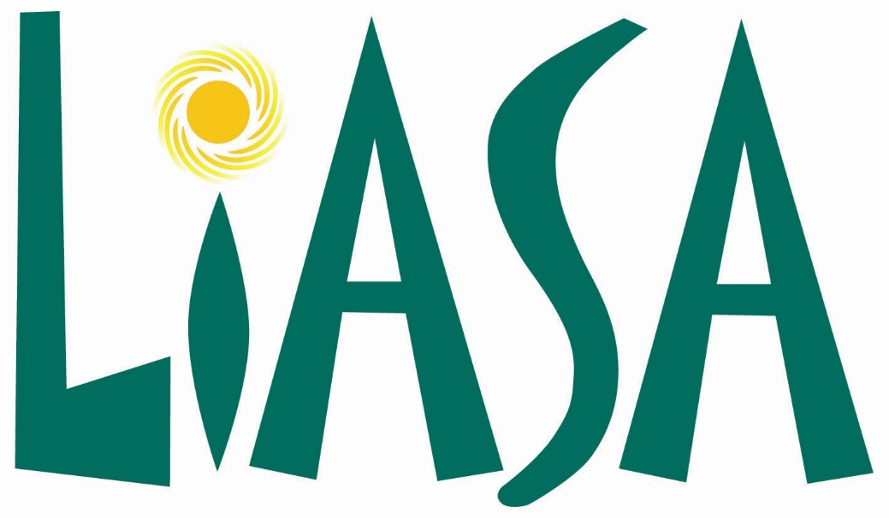

19th LIASA ANNUAL CONFERENCE

8 – 12 October 2018
Cape Town International Convention Centre (CTICC 2)
Cape Town, South Africa

Sponsorship & Exhibition Prospectus

Enquiries and Contact Details:

Annamarie Goosen Charlene Tlhabane
LIASA Manager LIASA Conference: Project Manager
E-Mail: manager@liasa.org.za E-mail: Charlene@soafrica.com

ABOUT LIASA
The Library and Information Association of South Africa (LIASA) is the SAQA accredited Professional Body for the Library and Information Services sector and a non-profit organization uniting and representing all institutions and people working in libraries and information services in South Africa. It strives to unite, develop and empower all people in the library and information field into an organization that provides dynamic leadership in transforming, developing and sustaining library and information services for all people in South Africa.

21 years ago the library and information community of SA launched a unified Library and Information Association departing from the old way of existing as separate associations based on race and qualifications. This important step enabled all library and information workers to speak with one voice and to promote their services to their users, the broader community, civil society and decision makers. These efforts contribute to the understanding of the important role that libraries play in a democratic society, advancing literacy, making the basic human right of freedom of access to information a reality, and in promoting tolerance and respect among all South Africans.

The existence of library services in all communities of SA empowers the public at large to participate fully in the new democratic society and play an important role in supporting education and life-long learning. For more information you can visit our website at www.liasa.org.za.

LIASA 19TH ANNUAL CONFERENCE
The Library and Information Association of South Africa hosts an annual conference. The conference is a professional event for librarians, library managers and library practitioners to debate, discuss and share issues of professional interest including;
- Training
- Practice
- Academic Issues
- Specialisation
- Networking

CONFERENCE THEME
“Libraries and Information Services: Agents for Community Development and Social Transformation”

WHO WILL BE ATTENDING
Traditionally the conference attracts between 600 and 800 delegates including;
- LIASA Members
- Library Directors
- Library Managers
- Library Support Staff
- Suppliers to Libraries
- Government
- Academics
- Students

Registration Fees

Early Bird Registrations (including 15% VAT) (26 March – 31 July 2018)
Member: R5 100.00
Non-member: R7 700.00
Pensioners: R3 340.00
Students: R3 340.00

Day Registration – LIASA Member: R1 800.00
Day Registration – Non-member: R2 400.00
Day Registration – Pensioner: R1 100.00
Pre-Conference Workshop - Member: R750
Pre-Conference workshop – Non-member: R950
City Tour - Member: R850
City Tour – Non-member: R1 050

Standard Registration (including 15% VAT) (1 August – 1 September 2018)
Member: R6 800.00
Non-member: R9 800.00
Pensioners: R3 340.00
Students: R3 340.00

Day Registration – LIASA Member: R1 800.00
Day Registration – Non-member: R3 400.00
Day Registration – Pensioner: R1 100.00
Pre-Conference Workshop - Member R750
Pre-Conference Workshop – Non-member: R950
City Tour - Member: R850
City Tour – Non-member: R1050

Important Registration Deadlines

Call for Registration: 26 March 2018
Early Bird Deadline: 31 July 2018
Online Registration Closes: 1 October 2018

Registration Coordinator
For any registration queries/information or quotations, please contact

Tammy Maart – Scatterlings Conference & Events
021 422 2402
Tammy@soafrica.com

Programme Outline

Sunday 07 October 2018
11:00 – 18:00 Representative Council Meeting

Monday 08 October 2018
10:00 – 16:00 Pre-Conference Workshops
11:00 – 16:00 City Tour

Tuesday 09 October 2018
08:30 – 17:30 Conference proceedings
18:00 – 21:00 Exhibition Opening and Welcome Cocktail

Wednesday 10 October 2018
08:30 – 17:30 Conference proceedings

Thursday 11 October 2018
08:30 – 17:30 Conference proceeding
LIASA AGM
19:00 – 23:00 Awards Ceremony and Gala Dinner

Friday 12 October 2018
08:30 – 12:30 Conference proceedings
13:30 – 18:00 Representative Council meeting

Programme Subject to change.

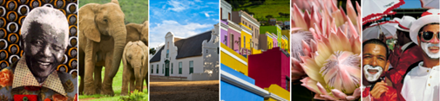

Venue

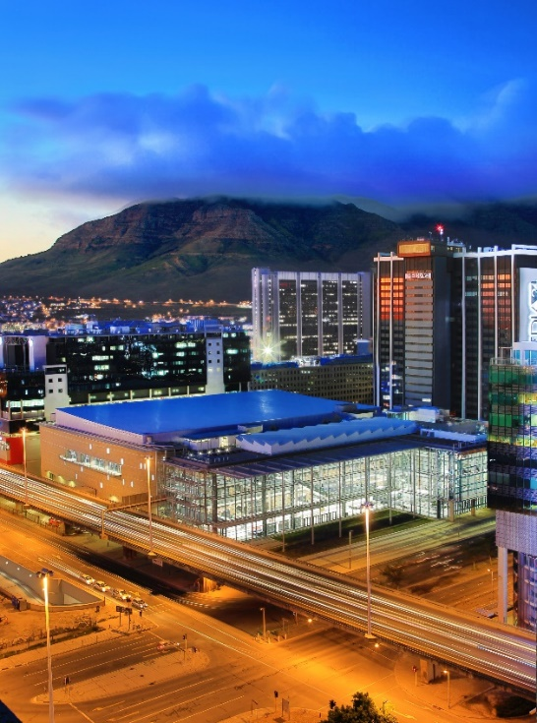

The CTICC’s stylish new building has been formally named CTICC 2. CTICC 2 has been designed as a seamless extension of the original building, now called CTICC 1, to provide complementary space for large exhibitions or conferences. As such the integration of the two buildings will allow them to form an event venue complex that will affirm Cape Town’s commitment to developing business tourism and driving the knowledge economy of South Africa. However, CTICC 2 will also be able to operate as an entirely independent facility.
WATER CRISIS:
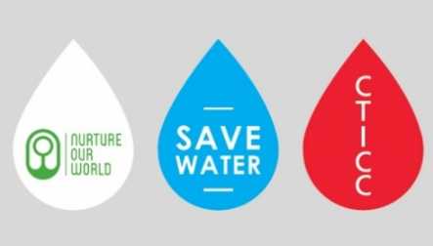
Read more about the water crisis: www.cticc.co.za/blog/cape-towns-water-crisis-your-event-questions-answered
MAP/DIRECTIONS
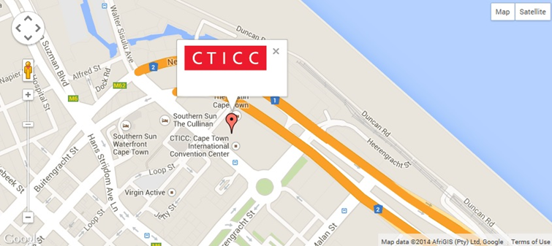
The 362 bays on P3 are situated in the CTICC 1 basement.
Item | Opportunity  Sponsorship opportunities for 2018  Based on 700 delegates | Cost | Detail
1 | Welcome Function and Exhibition Opening | R 100,000 | Sponsor and LIASA co-branding at the function  Acknowledgement with a 100 word company write-up, logo and URL link on conference website and final programme  6 Complimentary guests to attend the Welcome Function and Exhibition Opening  Co-branding on all material and communication related to the Welcome Function and Exhibition Opening  One page insert into delegate bag  Sponsor can provide branded aprons for waiter staff  Sponsor can provide branded table clothes  Sponsor may have their CEO deliver the welcome address at the function  Acknowledgement on the LIASA website  Logo to be included in the looped presentation of major sponsors
2 | Delegate Conference Bags | R 85,000 | Sponsor and LIASA co-branding on the conference bag  Acknowledgement with a 100 word company write-up, logo and URL link on conference website and final programme  One page insert into delegate bag  3m x 3m exhibition stand incl. 2 staff to manage the stand  Acknowledgement on the LIASA website  Logo to be included in the looped presentation of major sponsors
3 | USB’s | R75,000 | Sponsor and LIASA co-branding on the conference USB  Acknowledgement with a 100 word company write-up, logo and URL link on conference website and final programme  Full page advertisement on memory sticks  3m x 3m exhibition stand incl. 2 staff to manage the stand  Acknowledgement on the LIASA website  Logo to be included in the looped presentation of major sponsors
4 | Conference book of Abstracts and Final Programme | R 60,000 | Sponsor and LIASA co-branding on the conference programme’s front cover  Double page advertising space in the booklet  Acknowledgement with a 50 word company write-up, logo and URL link on conference website and final programme  1x Complimentary Delegates  Acknowledgement on the LIASA website  Logo to be included in the looped presentation of major sponsors
5 | Conference Folders | R40,000 | Sponsor and LIASA co-branding on the conference folder  Acknowledgement with a 50 word company write-up, logo and URL link on conference website and final programme  One page advertising space in the programme booklet  Acknowledgement on the LIASA website  Logo to be included in the looped presentation of major sponsors
6 | President’s Dinner (40 guests) | R30,000 | Sponsor and LIASA co-branding on all material and communication regarding the President’s Dinner  Branding opportunity on dinner menus, guest gifts, and at the restaurant (subject to approval by the relevant authorities)  Acknowledgement with a 50-word company write-up, logo and URL link on conference website and the final programme  One page insert into conference bags  Acknowledgement on the LIASA website  Logo to be included in the looped presentation of major sponsors
7 | Delegate Lanyards and Name Badges | R 25,000 | Sponsor and LIASA co-branding on lanyards and name badges  Acknowledgement with the logo and URL link on conference website and the final programme  Acknowledgement on the LIASA website  Logo to be included in the looped presentation of major sponsors
8 | Hospitality Sponsor for Conference lunches | R 20,000 per day | Sponsor and LIASA co-branding of the lunch area for the day  Branding opportunity on the lunch vouchers or wristbands  Acknowledgement with the logo and URL link on conference website and the final programme  Acknowledgement on the LIASA website  Logo to be included in the looped presentation of major sponsors
9 | Conference Notepads and pens | R20, 000 | Sponsor and LIASA co-branding of the A5 conference notepads  Acknowledgement with the logo and URL link on conference website and the final programme  Acknowledgement on the LIASA website  Logo to be included in the looped presentation of major sponsors
10 | Gala Dinner Table | R8 000 per table of 10 | Includes:  10 tickets to the dinner  Wine, juice and water on the table  Reserved table
11 | Inserts into delegate bag | R 5,00 per bag (x approx.. 700 bags) Estimate  R 3,500 | One page insert into the delegate bags  Acknowledgement on the conference website and the final programme  Acknowledgement on the LIASA website  Logo to be included in the looped presentation of major sponsors
12 | Speaker Gifts | TBC – dependant on number of speakers | Branding of speaker gifts  Acknowledgement with the logo and URL link on conference website and the final programme  Acknowledgement on the LIASA website  Logo to be included in the looped presentation of major sponsors

Exhibition information

Shell Scheme Exhibition - NON-LIASA Members
R19 500 including 15% VAT.
This includes:
- Floor space 3m x 3m
- Fascia (max 25 letters)
- 2 x spotlights
- 1 x standard power point
- 1 x table and 2 x chairs
- 2 exhibitor registration badges

Shell Scheme Exhibition - LIASA Institutional Paid-up Member
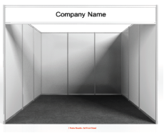
R16 575 including 15% VAT
This includes:
- Floor space 3m x 3m
- Fascia (max 25 letters)
- 2 x spotlights
- 1 x standard power point
- 1 x table and 2 x chairs
- 2 exhibitor registration badges

Shell Scheme Exhibition: NON-LIASA MEMBERS
R14 000 including 15% VAT
This includes:
- Floor space 2m x 2m
- Fascia (max 25 letters)
- 2 x spotlights
- 1 x standard power point
- 1 x table and 2 x chairs
- 1 exhibitor registration badge

Shell Scheme Exhibition: LIASA Institutional Member (paid up)
R9 000 including 15% VAT
This includes:
- Floor space 2m x 2m
- Fascia (max 25 letters)
- 2 x spotlights
- 1 x standard power point
- 1 x table and 2 x chairs
- 1 exhibitor registration badge

Display Table: R2 000 (exclusively for Library Schools – no exceptions will be made)
No complimentary delegates – paid conference delegates should manage the table.

Additional Benefits
When you exhibit your company will receive the following additional benefits:
- Listing as an exhibitor on the conference website prior to the conference with a link to the company website
- Listing in the final programme

Allocation of Exhibition Space
Space allocation will be made on a “first come, first served” basis after platinum, gold and silver sponsors have selected their stands.
Space allocations will be made in the order in which application forms with the deposit payment are received.

Exhibition Manual
An Exhibition Manual outlining all technical aspects of exhibiting will be circulated at the beginning of August 2018. It will include the following:
- Technical details about the Venue
- Final exhibition details and information
- Contractor details
- Services available to exhibitors and order forms

Contact Information

For the LIASA Annual Conference
Annamarie Goosen
LIASA Manager
manager@liasa.org.za
conference@liasa.org.za
012 324 6096

Charlene Tlhabane
Conference Project Manager
charlene@soafrica.com
011 463 5085

For general communication:
Mandla Ntombela
LIASA President
president@liasa.org.za
083 478 4626

Nikki Crowster
LIASA President-Elect
nikki.crowster@uct.ac.za
082 822 2120

Annamarie Goosen
LIASA Manager
manager@liasa.org.za
012 324 6096

